**Name:** Sadia Barkat

**Roll No:** 131214

**Class:** Saturday (2-5)

**Day 5: Testing , Error handling and Backend Integration Refinement:-**

*Functional Deliverables:

Website is fully responsive.

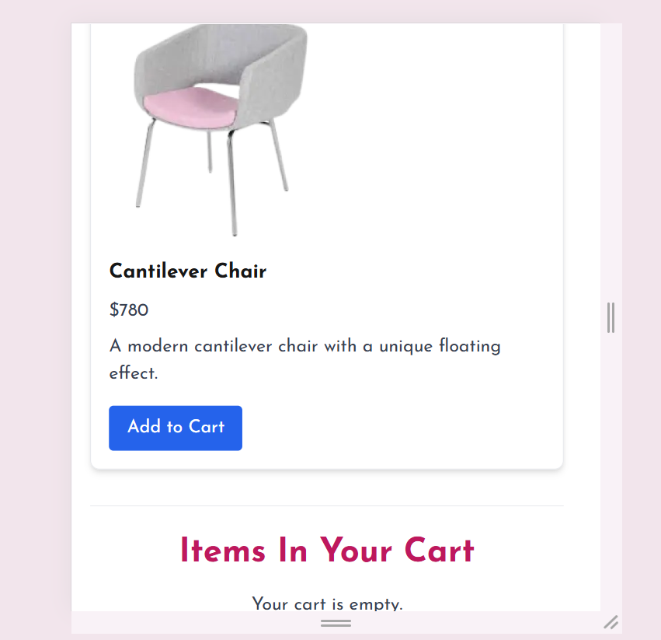

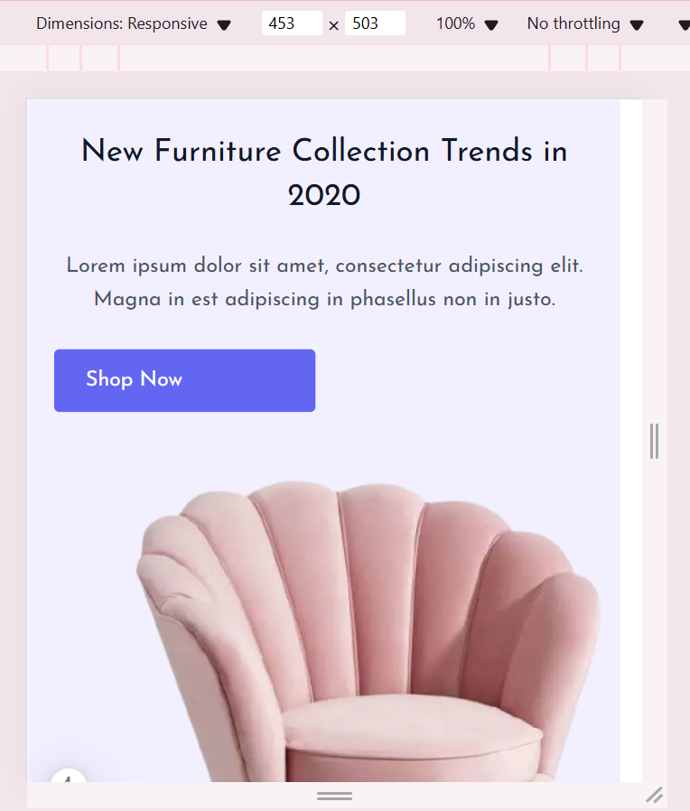

*Checking status of API through Thunder Client:

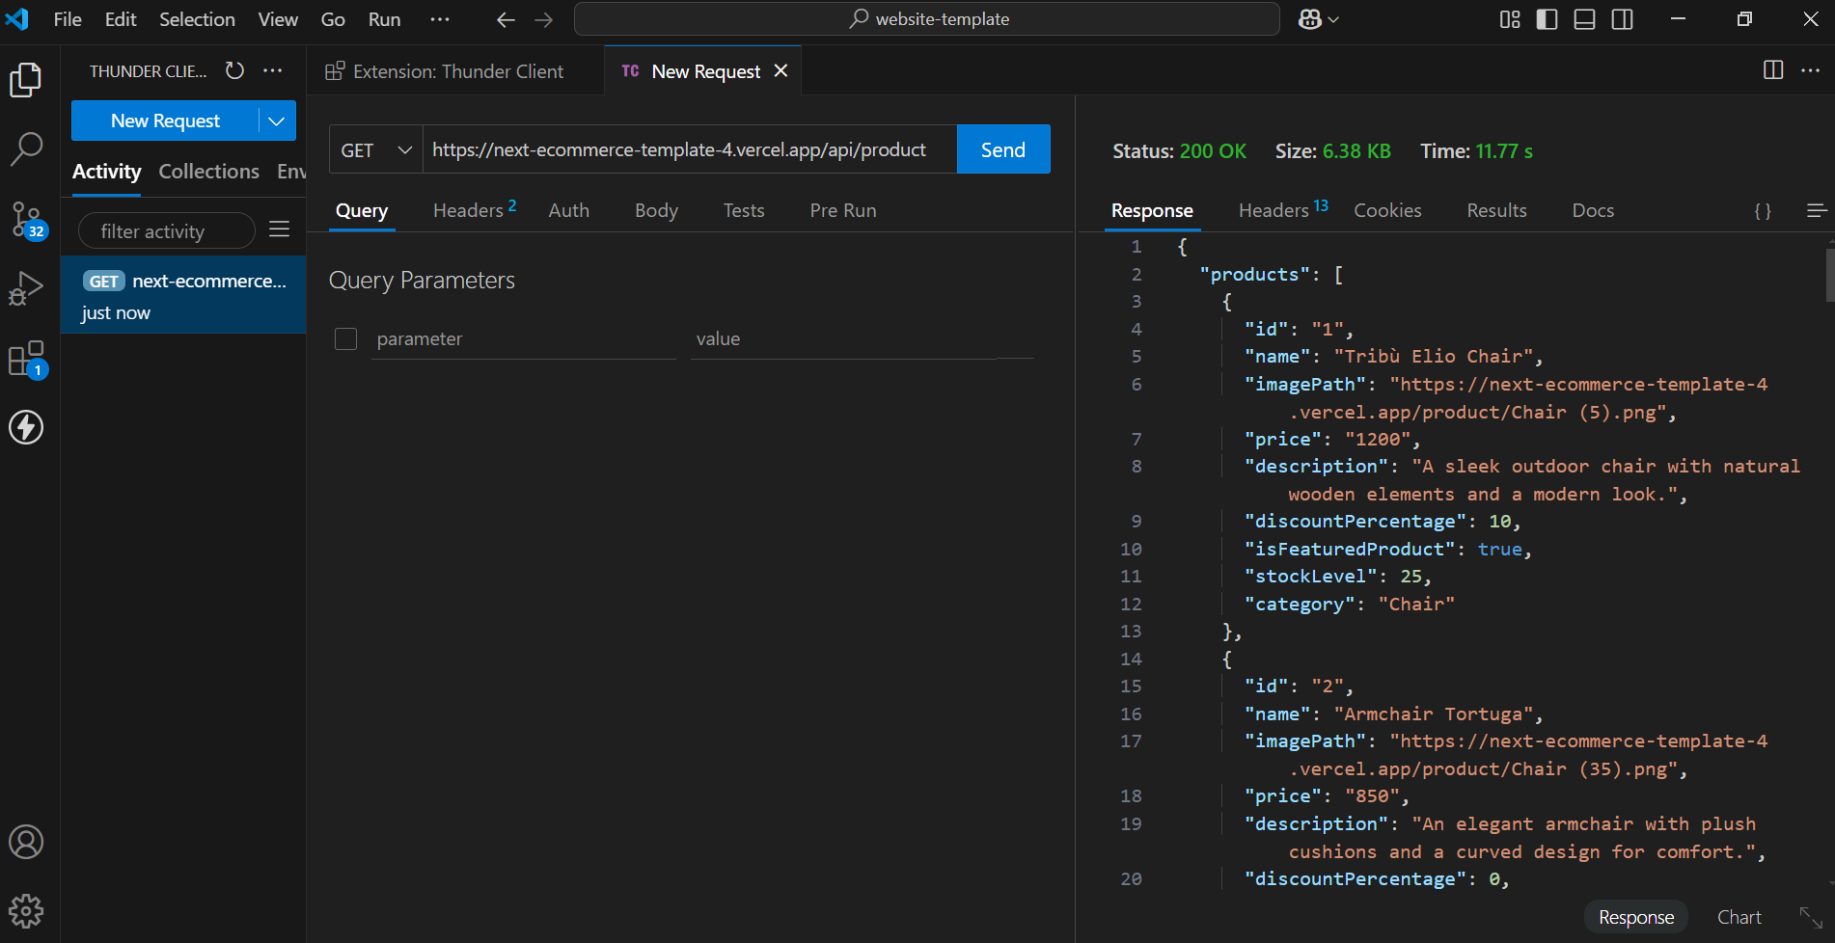

*Test Report:

|  |  |  |  |  |  |  |  |  |  |
| --- | --- | --- | --- | --- | --- | --- | --- | --- | --- |
|  | Test case ID | Description | Test steps | Expected Result | Actual Result | Status | Security Level | Assigned to | Remarks |
| 1 | TC001 | Product Listing | Open product page>Verify products | Product displayed correctly | Product displayed correctly | Passed | Low | - | No issue |
| 2 | TC002 | Test API Error handling | Disconnect API > refresh page | Show fallback UI with error | Error message shown | Passed | Medium | - | Test successful |
| 3 | TC003 | Cart functionality | Add product in cart>verify | Cart update when product added | Cart update when product added | Passed | High | - | No issue |
| 4 | TC004 | Responsive on mobile | Resize browser | Layout adjust properly | Layout adjust properly | Passed | Medium | - | No issue |

*Performance Optimization:

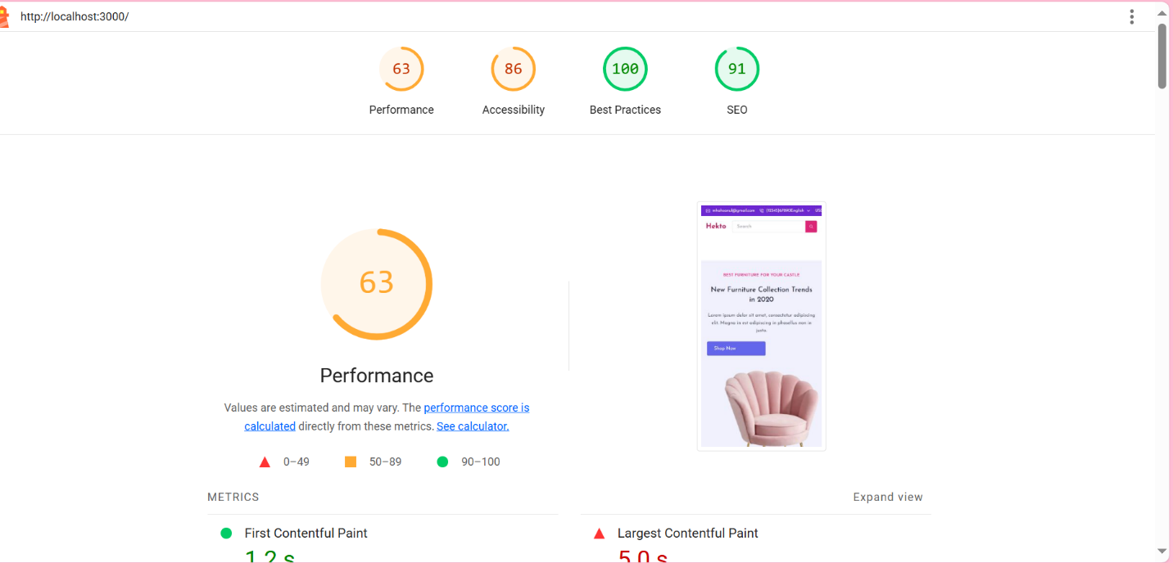

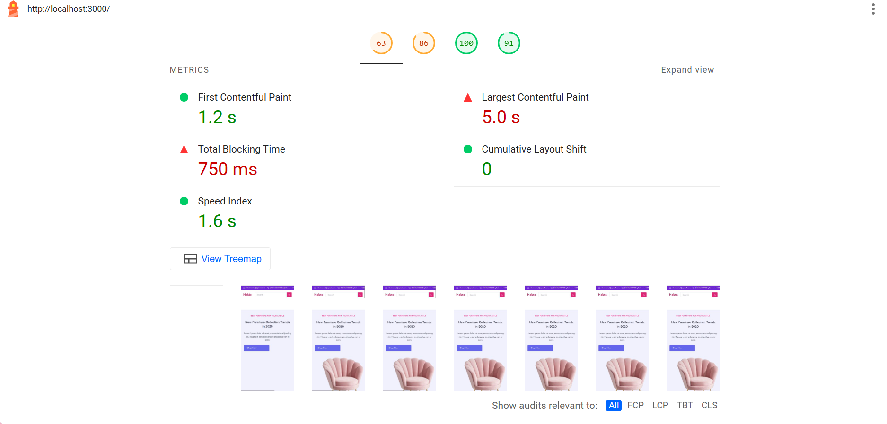

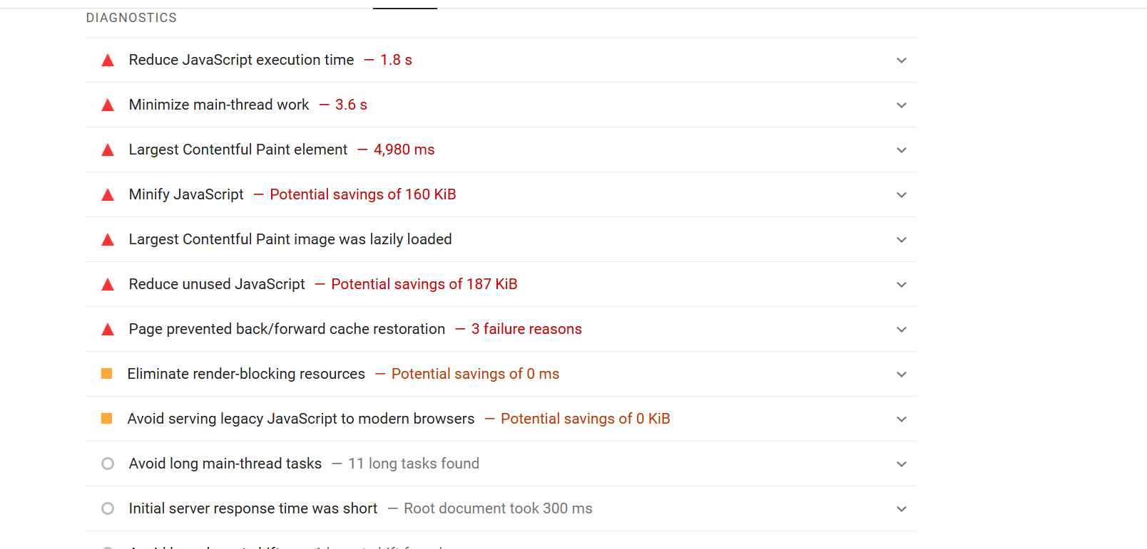

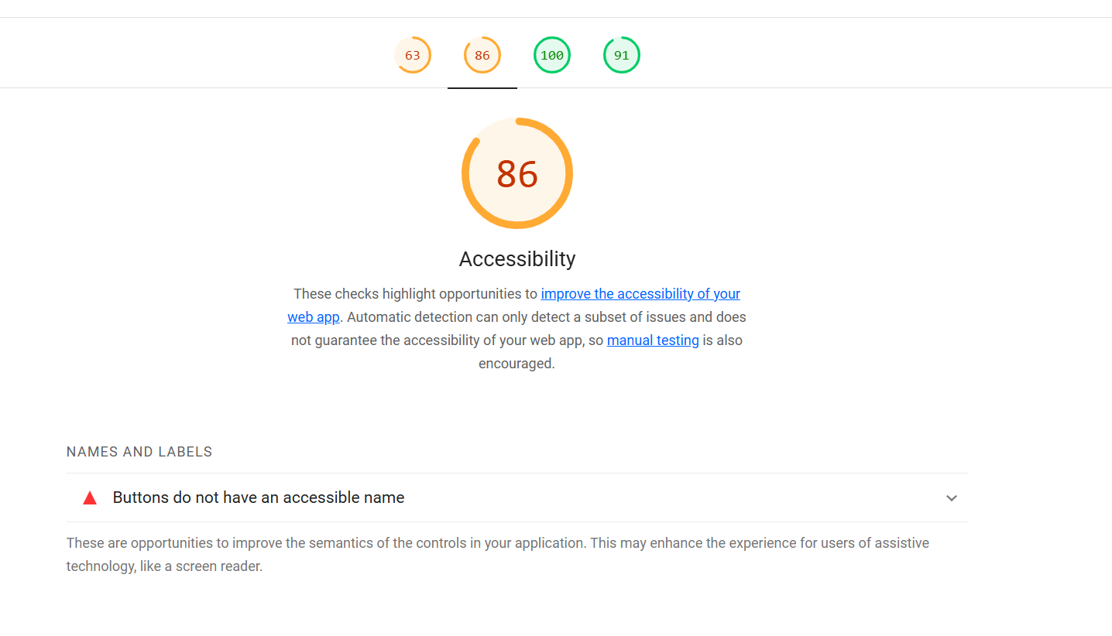

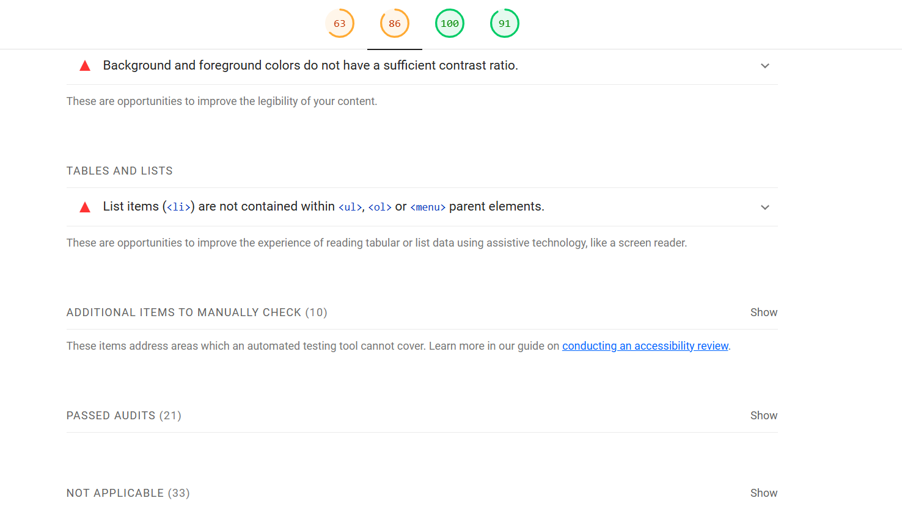

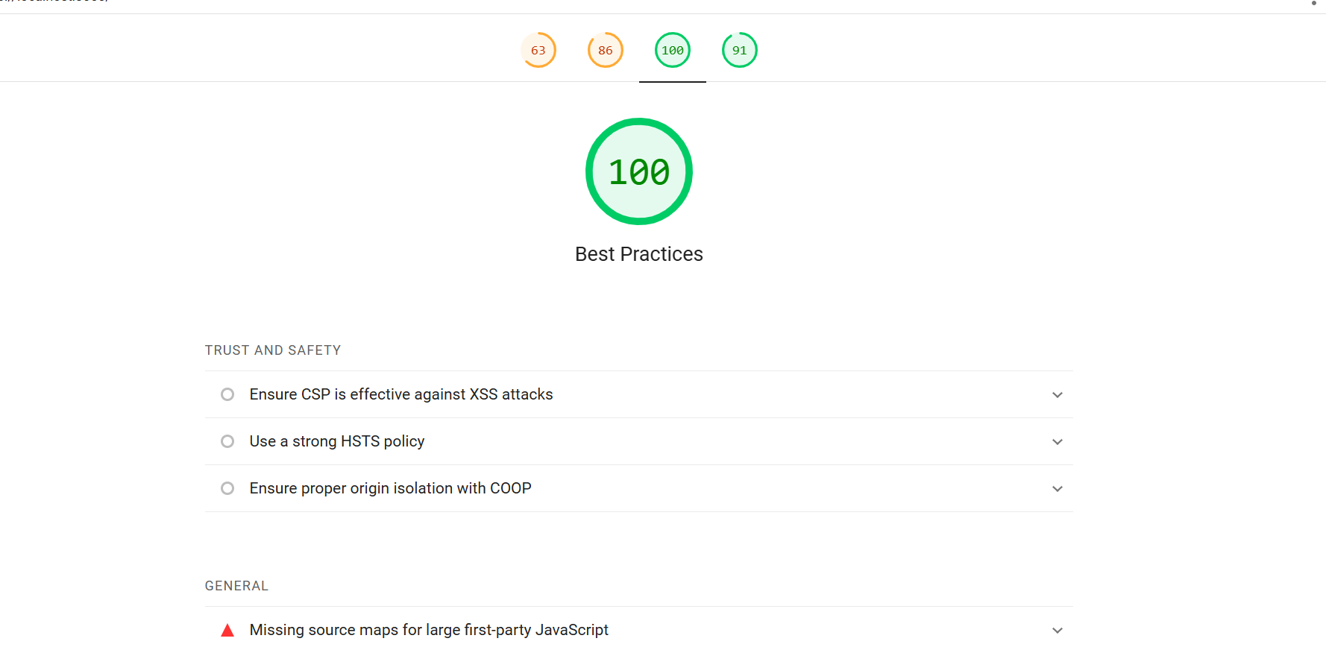

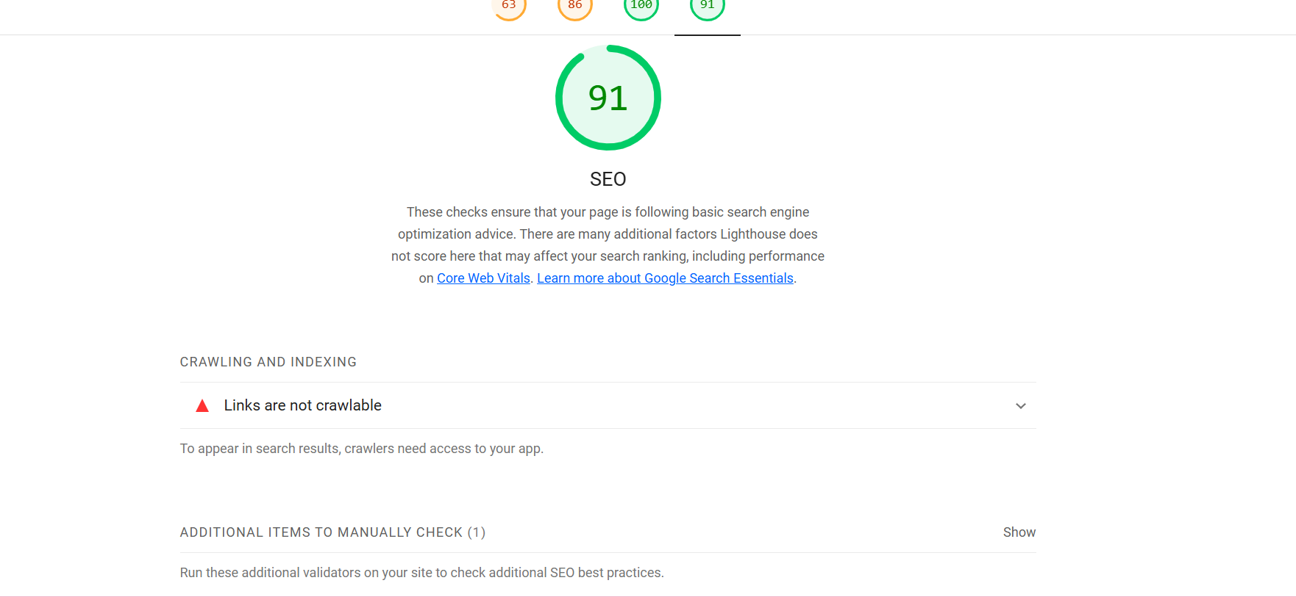

*Developer Resources:

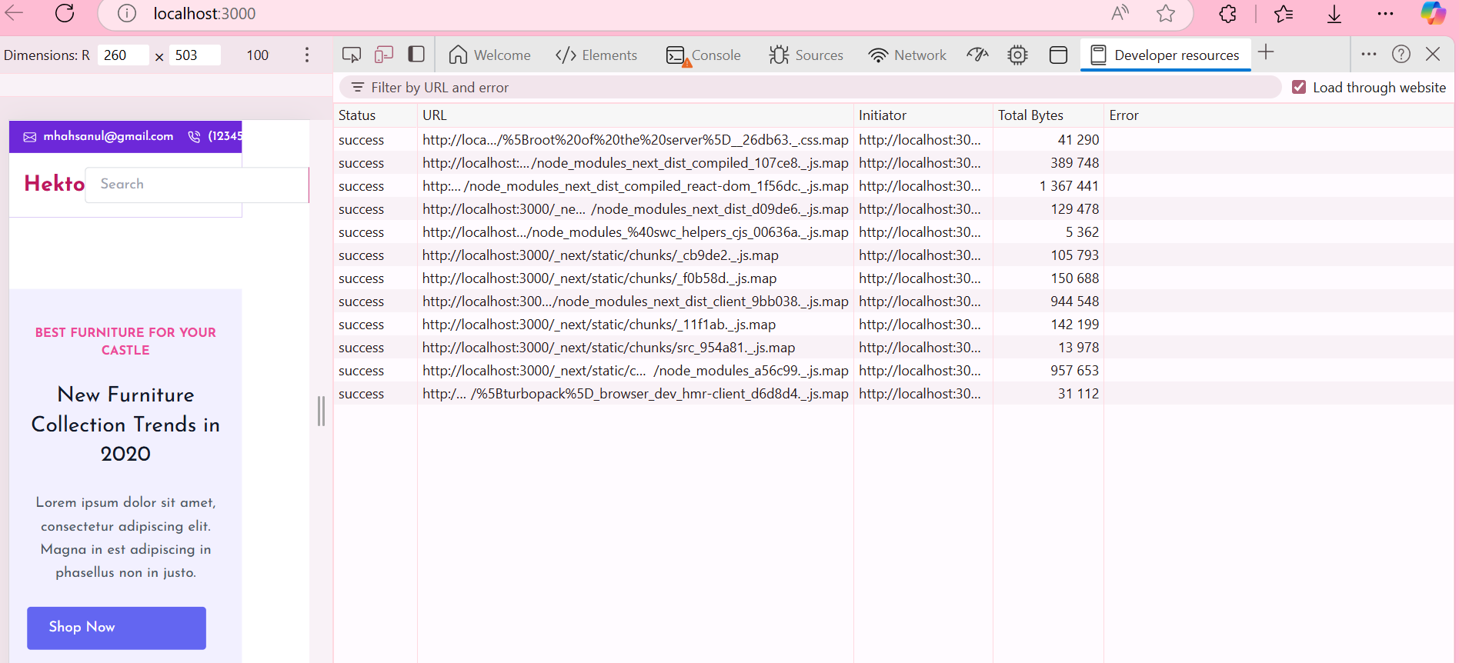

*Performance Monitor:

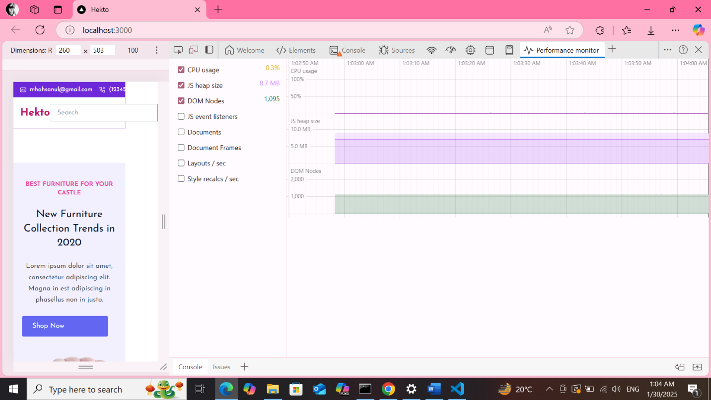

*Security Overview:

